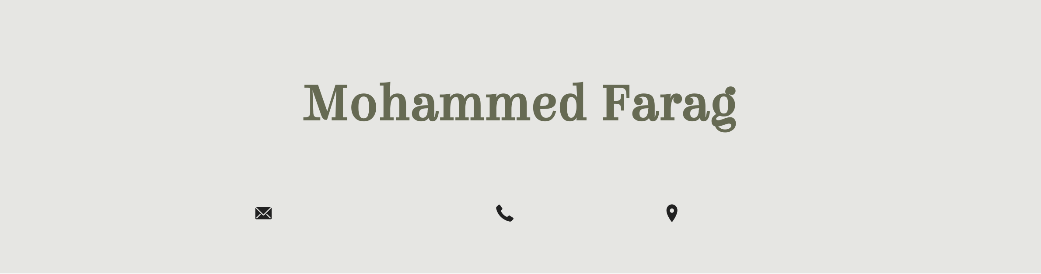

Mohammed Farag

*Python Engineer*

|  |  |  |
| --- | --- | --- |
| mmusa3914@gmail.com | +966543769518 | Riyadh , KSA |

**PROFILE**

Solution-focused Python Developer with 3+ years of experience developing web applications using Python Django. Instrumental in writing code, implementing Python applications, ensuring data security and protection, and identifying data storage solutions. Expertise in data processing automation using python, machine learning, and multi-process architecture. MatPlotlib | Pandas | Django | TensorFlow | Flask | Python programming | Cloud computing ‘Azure’ | Machine Learning | Data Science.

**SKILLS**

**Skills**  
• Strong knowledge and expertise in the Python programming language, including its syntax, data structures, libraries, and frameworks. .

• Experience in web development using Python frameworks and Knowledge of machine learning techniques for data analysis and predictive modeling.

• Knowledge of working with databases and Cloud Technologies: Experience working with cloud platforms like AWS, Azure, or GCP for data storage and processing.

• Good in Data Warehousing Building and maintaining data warehouses for large-scale data storage and analysis.

• Big Data Technologies Working with distributed storage and processing frameworks such as Hadoop, Spark, and NoSQL databases.

• Familiarity with ETL (Extract, Transform, Load): Extracting data from various sources, transforming it into a suitable format, and loading it into the target data storage or data warehouse.

• Good Knowledgecwith implementing CI/CD , Basic knowledge with Docker , Azure Machine Learning.

• A passion for continuous learning and staying updated with the latest trends, libraries, and frameworks in the Python ecosystem. The ability to adapt and learn new technologies.

**PROFESSIONAL EXPERIENCE**

**Application Engineer,**  07/2023 – present

**General Authority for Survey and Geospatial Information**  Riyadh, Saudi Arabia

•Provide clients with technical support as needed and relay information to our development teams for ongoing maintenance and update needs.

•Optimize applications by integrating new technologies and performing upgrades.

•Contribute to sales presentations, as well as demonstrating prototypes and completed applications.

•Perform diagnostic tests and debugging procedures while improving code and re-designing tasks.

•Generate ideas for software innovation based on market trends

•Document development processes, procedures and application version histories.

1 / 3



•Keep up with advancements in application engineering and new technologies.

**Appliation Engineer L2,**  09/2022 – 07/2023

**B2BROKER - LIQUIDITY & TECHNOLOGY PROVIDER**  Dubai,

•Providing software application support under the supervision of the Senior United Arab Emirates

Engineer.

•Performing analyses on software application functionality and suggesting

improvements.

•Ensuring effective front-end and back-end functionality of applications.

•Consulting with the software development team, internal users.

•Keeping a record of configuration changes and scheduling application updates.

•Documenting processes and monitoring application performance metrics.

•Providing front-end support to clients and colleagues in other departments.

**Software Engineer,**  12/2020 – 09/2022

**GOVERNMENT OF SHARJAH SHARJAH ARCHAEOLOGY AUTHORITY**  Sharjah,

•Develop flowcharts, layouts and documentation to identify requirements and United Arab Emirates

solutions

•Write well-designed, testable code

•Integrate software components into a fully functional software system

•Troubleshoot, debug and upgrade existing systems

•Deploy programs and evaluate user feedback

•Ensure software is updated with latest features

**PYTHON DEVELOPER, Contact Me -Remote**  10/2021 – 03/2022

•Develop back-end components to improve responsiveness and overall Khartoum, Sudan

performance.

•Writing scalable code using Python programming language.

•Testing and debugging applications.

•Developing back-end components.

•Test and debug programs

•Improve functionality of existing systems

**SOFTWARE ENGINEER, AL JAZEERA SUDANESE JORDANIAN BANK**  10/2019 – 11/2020

•Coordinating with development teams to determine application requirements. Khartoum, Sudan

•Writing scalable code using Python programming language.

•Testing and debugging applications.

•Installing computer hardware configurations.

•Installing software and networking systems.

•Fixing hardware, software, and networking issues.

•Resolve issues for staff via phone, in person, or electronically

**SOFTWARE DEVELOPER, MINISTRY OF HIGHER EDUCATION**  10/2017 – 10/2019

•Testing and debugging applications. Khartoum, Sudan

•Developing back-end components.

•Integrating user-facing elements using server-side logic.

•Assessing and prioritizing client feature requests.

•Coordinating with front-end developers.

•Reprogramming existing databases to improve functionality.

•Modifying software to fix errors, adapt it to new hardware.

**EDUCATION**

**BSc (Hons) Computer Science & IT, Al Neelain University**  Khartoum, Sudan

2 / 3



**LANGUAGES**

|  |  |  |  |
| --- | --- | --- | --- |
|  | Arabic |  | English |

**CERTIFICATES**

IBM Data Engineering

Data Science with Python Complete Course - Udemy

Master Python With NumPy For Data Science & Machine Learning - Udemy

3 / 3